Welcome to the latest edition of the weekly Somerset Covid-19 update for key stakeholders. The update is produced on behalf of the Somerset Covid-19 Engagement Board and is designed to provide a weekly update on the current Covid-19 situation in Somerset.
Friday 26 March 2021
Somerset’s Covid-19 Weekly Update

Somerset’s seven-day infection rate has varied slightly to last week’s rate of 39.3 and now stands at 38.2 new cases per 100,000.

Data is showing the case rates in Somerset plateauing, showing small variations daily but hovering around the same figure. This is in part due to the increased numbers of people being tested which allows us to case find and take public health action early; avoiding the virus being spread to others.

The vaccination progress goes from strength to strength with almost 295k of the Somerset population having received a first dose of vaccine.

As we open up society, we will expect numbers to increase and will be encouraging people to get tested if they have symptoms at one of our testing sites across the county.
It is going to be important that we take a cautious approach as we begin to socialise more with others from 29 March. The next few weeks will determine how the Government decide to move forward with the next phase of the roadmap; we mustn’t do too much too quickly and allow our rates and case numbers to creep up again. Please help us share our One day at a time campaign from 29 March, more on that later.

Many asymptomatic testing programmes (regular testing for those without symptoms) are well underway including testing in schools, care settings and workplaces but regular asymptomatic testing has now been made available to many more groups locally, including if you are a parent, or part of a household, childcare bubble or support bubble of school staff or a pupil at nursery school or college. More information further down in this update. People taking part in this testing on a regular basis is going to be really important as we move forward as it helps to break the chain of transmission that might otherwise have gone unidentified.

The link below shows the Somerset Dashboard which tracks our local epidemic from the start in March 2020, to the current time:

https://www.somerset.gov.uk/covid-19-dashboard/

‘Remember, everyone can catch it, anyone can spread it’.

Clare Paul, Cabinet Member for Public Health and Wellbeing
Twitter: @Clarepaul_

Trudi Grant
Director of Public Health
Twitter: @SomersetDPH

David Fothergill
Leader of
Somerset County Council
Twitter: @DJAFothergill

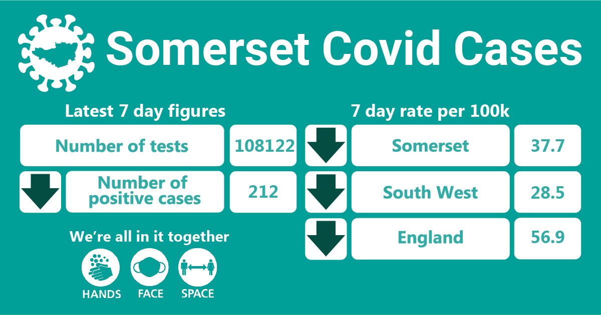
In week up to the 21st March, approximately 108122 tests were carried out across the county and there have been 212 new confirmed cases. The rise in tests and number of cases found is largely due to the increased lateral flow testing programmes and therefore identifying more asymptomatic cases. Our rate now however is higher than the South West rate of 28.5 so now, more than ever, we must keep up all the protection good measures such as hands face and space.

THIS WEEK’S HEADLINES:
The main items this week that are featured in this update are:
- Schools, workplaces and care settings
- Revised Local Outbreak Management Plan
- New Shielding advice from 1st April
- Lateral Flow Testing
- Myth buster training and vaccination buddies
- One Day at a Time campaign
- Communications and Engagement
- Accessible resources

Workplaces: All businesses in England can register to order tests if the business is registered in England and its employees cannot work from home. Businesses must register on or before 31 March 2021 to get the forms they will need to order free lateral flow tests to test employees in the workplace here. Guidance for employers running testing programmes can be found here.

We are still seeing sporadic outbreaks occurring as people socialise in and around the workplace (where people cannot work from home). We continue to support these settings by providing public health advice and guidance around stopping the spread and reducing transmission. As employees start to return to the workplace in the coming months, it will be crucial that essential guidance such as Hands Face Space – in informal and formal work settings are adhered to, to keep everyone as safe as possible.

Care Sector: In the seven days to 21st March there were 9 cases across six care settings.

This is a continued and welcome reduction on last week’s care setting figures. We continue to support settings as needed with support and guidance on prevention measures.

For all the latest information and guidance related to Covid19 visit Coronavirus updates for Somerset Adult Care Providers – Somerset Safeguarding Adults Board (safeguardingsomerset.org.uk).

Schools and Early Years settings: In the week up to the 21st March there were 46 cases at nineteen school/college settings and 7 cases at five nurseries. This is an increase on last week but the increased regular asymptomatic testing taking place means that we are able to find more cases in people who are positive but do not have symptoms of Covid-19.

Guidance on how to use a home lateral flow test kit is available in other languages on this link to the Government website: COVID-19 PCR home test kit instructions - GOV.UK (www.gov.uk)

Revised Local Outbreak Management Plan: Local Authorities submitted revised Local Outbreak Management Plans to the Department of Health and Social Care on 12 March 2021. The revised plans are required to address all of the themes and issues which were addressed in the first plan, and in addition the plans must now address our local arrangements for responding to variants of concern, community testing, contact tracing and all aspects of outbreak management. The plan is currently subject to peer review and will be published when this review is completed.

Shielding advice for the clinically extremely vulnerable to stop from April:
Clinically extremely vulnerable people in England will be informed they are no longer advised to shield from Thursday 1 April 2021. We will be working with community and voluntary sector colleagues to support people with this transition. For more information, visit: https://www.gov.uk/government/news/shielding-advice-for-the-clinically-extremely-vulnerable-to-stop-from-april

Community Testing using lateral flow tests: Rapid testing continues to be part of Somerset’s Testing Strategy, which aims to identify cases of Covid-19 in order to break chains of transmission and protect those who are vulnerable.

In Somerset, targeted community testing has already been in place for workers who care for vulnerable groups such as the elderly in their own homes. This testing sits alongside the multitude of national testing programmes. Somerset County Council’s Public Health has now expanded the offer and free, rapid lateral flow Covid-19 tests are now being offered to:
- Anyone whose job or volunteering work requires them to leave the house and be in contact with others
- Anyone who cares for others, either paid or voluntary
To book your test, please click here: https://somerset.maps.test-and-trace.nhs.uk/

If you are a parent, or part of household, childcare bubble or support bubble of school staff or a pupil – you can now collect testing kits for you to do on yourself. Free ‘lateral flow’ test kits are available to collect from test sites across Somerset.
Six existing Local Testing Sites are operating as a Community Collect sites for households to collect lateral flow tests, please see locations below:
- Bridgwater and Albion Rugby Football Club
- Alcombe Children’s Centre, Minehead
- 19 Commercial Road, Shepton Mallet
- Broughton House, Taunton
- Wiveliscombe Rugby Football Club
- HMS Heron, RNAS Yeovilton, Yeovil

Visit https://www.somerset.gov.uk/coronavirus/covid-19-lateral-flow-test/ to view these locations on a map. You do not need to book ahead if you are collecting a test kit to take away.

Children returning to or continuing in secondary schools or further education colleges, as well as school staff in all education settings including nurseries, are being offered lateral flow (rapid) tests through a separate Government scheme

To find out about Government testing schemes for workplaces please visit: https://www.gov.uk/get-workplace-coronavirus-tests

Lateral flow testing involves a swab of the nose and throat to collect a sample and provides a result within around half an hour. This screening test requires twice weekly testing.

- If you test negative
If your Lateral Flow Test result is negative, you have no symptoms and are not a close contact of someone who has coronavirus, you do not need to self-isolate but must continue the useful guidelines around Hands Face Space
- If you test positive
If your Lateral Flow Test result is positive, you will need to self-isolate with the rest of your household

Guidance on how to use a home lateral flow test kit is available in other languages on this link to the Government website: COVID-19 PCR home test kit instructions - GOV.UK (www.gov.uk)

Covid-19 Vaccine Myth Buster Training: With confidence around the vaccine wavering within particular groups, vaccine buddies will be a key part of ensuring that people get the right information from official sources and are reassured and informed about the vaccination process and its importance. In collaboration with Spark Somerset we are offering Vaccination Myth Buster Training to anyone who is able and willing to have conversations about the vaccine.

People attending this training will also be offered the opportunity to become Vaccination Buddies: specially trained volunteers who can have supportive telephone calls with people that have questions and concerns about the Covid-19 vaccine.

If you would like more information, please don’t hesitate to get in touch with Helen, Covid Community Champion Coordinator at: Helen.Fielden@sparksomerset.org.uk

The training will be on Zoom on Wednesday 31st March, 7-8.30pm.

To find out more, and to book your place click here.

One Day at a Time campaign: As we come out of lockdown and are able to slowly start meeting people again outdoors in groups of six or two households; we will encourage Somerset communities to take a careful approach to enjoying new freedoms, one day at a time whilst remembering the importance of hands, face, space to keep everyone safe. The campaign will remind people that the roadmap dates are all to be based on data and may change if numbers increase. It is with a collective effort of acting responsibly and cautiously that we can return to a new normal.

Communications and Engagement:
- Promotion of the One day at a Time campaign –
- Promotion of latest Somerset Covid Catch up Video – This week's Covid Catch-up video, former BBC Correspondent Clinton Rogers focuses on carers, the challenges they’ve faced, and the support that’s available to them – watch the video: https://bit.ly/3lJ2ZMF
- Promotion of short videos fronted by medical professionals from Black, Asian and minority ethnic (BAME) communities discussing common questions and concerns around the Covid-19 vaccine. These have been produced in collaboration with Somerset Diverse Communities (part of CCS) and the Somerset Foundation Trust. The videos can be seen on SCC’s YouTube Channel here: https://youtube.com/c/SomersetCountyCouncilOfficial
- Translated materials on frequently asked questions on the Covid-19 vaccine are in development and will be shared as soon as they are ready
- Vaccine Myth buster training webinar promotion and continued Covid Community Champion and vaccination buddy recruitment
Resources and further information: Please do keep an eye our Healthy Somerset
website, which has a huge amount of information and resources to help keep everyone
healthy happy and safe at this time: https://www.healthysomerset.co.uk/covid-19/

For the latest local information as well as digital resources, posters and flyers please visit:
https://www.somerset.gov.uk/coronavirus/

The Somerset Local Outbreak Management Plan outlines how we, the council, will work
with the NHS Test and Trace Service, PHE, the NHS and other partners to ensure a whole
system approach to preventing and managing local outbreaks. This can be found here.

Finally, please like us on Facebook, follow us on Twitter and share our posts with your
networks to help us in communicating these important messages. Follow our Director of
Public Health account too here.

